Block 4
January 3- February 9
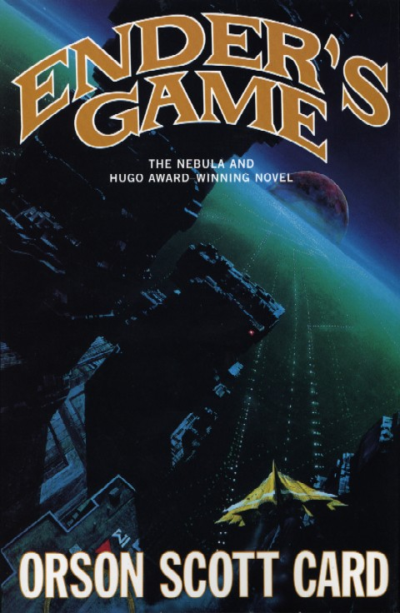

“Perhaps it's impossible to wear an identity without becoming what you pretend to be.”
― Orson Scott Card, Ender's Game

What influences a person’s identity?
For this block we will be studying the book “Ender’s Game”. We will be using this
book as a means to further explore our block’s theme of Identity.

Week 1:
Class Date | Assignment
Tuesday  Jan. 3 | Introduction
Thursday  Jan. 5 | Read pp. ix-26  Daily Response Questions  Prepared discussion

Week 2:
Class Date | Assignment
Tuesday  Jan. 10 | pp. 27-53  Daily Response Questions  Prepared discussion
Thursday  Jan. 12 | pp. 54-96  Daily Response Questions  Prepared discussion

Week 3:
Class Date | Assignment
Tuesday  Jan. 17 | pp. 97-119  Daily Response Questions
Thursday  Jan. 19 | pp. 120-153  Daily Response Questions  Prepared discussion

Week 4:
Class Date | Assignment
Tuesday  Jan. 24 | pp. 154-172  Daily Response Questions  Prepared discussion
Thursday  Jan. 26 | pp. 173-226  Daily Response Questions  Prepared discussion

Week 5:
Class Date | Assignment
Tuesday  Jan. 31 | pp. 227-254  Daily Response Questions
Thursday  Feb. 2 | pp. 255-324  Daily Response Questions  Prepared discussion

Week 6:
Class Date | Assignment
Tuesday  Feb. 7 | Final Project Work
Thursday  Feb. 9 | Final Project Due

Point Distribution:
Daily Response Questions | 5 points each day
Discussion Preparation & Participation | 10 each discussion
Final Project (see below for ideas) | 50

Ender’s Game Daily Response #1 pp. ix-26
1. Define the term endgame. With an understanding of this term's definition, consider the symbolic import of Ender s name. In a well-written paragraph, speculate on what this means.
2. What important characters are introduced in these pages?
3. What internal crises does Ender face, and how does he respond to them?
4. What questions do you have after completing this reading assignment?
5. Make one or two predictions based on events in this reading assignment. If your predictions are based on specific instances of foreshadowing, refer to those pages in MLA format when responding.

Prepared Discussion Question:
1. Explain what it means for Ender to born a Third. Show whether this is a negative or positive fact to his parents, his brother, his sister, and his classmates.
2. The government in Ender's world plays a definitive role in reproductive decisions, imposing financial penalties and social stigma on families who have more than two children, while exerting tremendous pressure on specific families, who show great genetic potential, to have a third like Ender. Is government ever justified in involving itself in family planning decisions? (Consider the strict policies that China has imposed on its populace: One couple, one child. Optional resources: http://english.peopledaily.com.cn/200209/01/eng20020901_102440.shtml. http://www.china.org.cn/english/2002/Oct/46138.htm.)

Ender’s Game Daily Response #2 pp. 27-53
1. In Chapter 5 a homesick Ender thinks of Peter. What does the reader know of Peter so far? What image of him has the narrator created? What specific effect has Peter had on Ender in Chapter 5 ?
2. Having begun classes at the Battleschool, Ender quickly makes a name for himself. How does Ender, using the student desks, subvert Bernard’s social dominance?
3. Consider the character of Ender. If you were a launchy in his class, how would you describe him to a launchy from another group?
4. What questions do you have after completing this reading assignment?
5. Make one or two predictions based on events in this reading assignment. If your predictions are based on specific instances of foreshadowing, refer to those pages in MLA format when responding.
6. What internal crises does Ender face, and how does he respond to them?

Prepared Discussion Questions:
1. The dubious character of Graff says to Ender, “Individual human beings are all tools, that the others use to help us all survive” (35). Argue for or against Graff s statement.
2. Do you view Ender as a strong or a weak person? Support your response with specific textual examples

Ender s Game Daily Response #3 pp. 54-96
1. When Ender and his fellow launchies first enter the battleroom, what does Ender immediately begin doing?
2. Each chapter begins with a secretive discussion held by two men, both of whom are involved in Ender’s training. First, what about Ender's fixation with the mind game concerns these two men? Second, briefly describe the game.
3. What internal crises does Ender face, and how does he respond to them?
4. What important events transpire in Chapter 7 ?
5. Who does Ender meet in Chapter 7? Briefly describing each, include any characters that seem important and you would expect to see again.
6. What questions do you have after completing this reading assignment?
7. Speaking with Petra, Ender silently identifies adults as enemies (85). Is this a logical conclusion for him to have drawn? Why or why not?

Prepared Discussion Questions:
1. The Fairyland that Ender encounters in the mind game is nightmarish. And it is extremely significant. Reread the sequence on pages 70 to 74. Unlike previous portions of the game, Ender s game character is a child, not an adult. How does this sequence symbolize Ender’s own childhood?

Ender s Game Daily Response #4 pp. 97-119
1. Define the terms xenophobia and genocide. What is the significance of each word in the context of this novel?
2. How is Ender received by his new army, Rat?
3. Reread pages 106-111, where Dink discusses childhood and the games being played. Summarize Dink’s remarks.
4. What internal crises does Ender face, and how does he respond to them?
5. What important plot complications transpired?
6. At the end of Chapter 8, Ender encounters not his image in the mirror, but Peter’s. What does this suggest about Ender? How does Ender respond to this suggestion?

Prepared Discussion Questions:
None!

Ender s Game Daily Response #5 pp. 120-153
1. What is Peter’s scheme, and why does Valentine agree to it?
2. What internal crises does Ender face, and how does he respond to them?
3. What important plot complications transpired?
4. What is hegemony?
5. Why does Graff approach Valentine?
6. Summarize the events that occur when Ender plays the mind game.

Prepared Discussion Questions:
1. Research the historical figures of John Locke and Demosthenes.
The following Internet sites should prove helpful: Hint: review each site before reading them thoroughly. http://plato.stanford.edu/entries/locke/ (just use the introduction). http://www.in2greece.com/english/historymyth/history/ancient/demosthenes.htm. http://www.hatrack.com/research/questions/q0027.shtml.
Summarize the life and ideas of each (looking at Card s site is essential). We will be discussing who they are!

Ender’s Game Daily Response #6 pp. 154-172
1. What important plot complications transpired?
2. What internal crises does Ender face, and how does he respond to them?
3. What is something you have particularly enjoyed about the novel at this point?
4. Make one or two predictions based on events in this reading assignment. If your predictions are based on specific instances of foreshadowing, refer to those pages in MLA format when responding.

Prepared Discussion Questions:
1. Why do you think Ender bullies Bean?
2. Is Ender a legitimate genius? Why or why not?

Ender’s Game Daily Response #7 pp. 173-226
1. What important plot complications transpired?
2. What internal crises does Ender face, and how does he respond to them?
3. What is something you have particularly enjoyed about the novel at this point?
4. What is strange about the footage of Mazer Rackham?
5. Why do you think the Battleschool's commanders hide Bonzo’s and Stilson’s deaths from Ender?

Prepared Discussion Questions:
1. Select one or two conflicts encountered by Ender in these two chapters. First, evaluate his response. Did he respond effectively or not? Explain. Second, how would you have responded differently to the conflicts, regardless of whether or not you felt he responded appropriately?
2. Ender returns to Earth, ostensibly for a vacation. How has he changed since he first left Earth?

Ender’s Game Daily Response #8 pp. 227-254

This chapter is crucial to the story's development. Develop four questions like those you’ve seen on previous daily responses, write them, and respond to each and be prepared to share. Do not duplicate any questions you’ve seen previously. Your questions and responses should focus on factors that make this chapter so critical.

Prepared Discussion Questions:
None!

Ender’s Game Daily Response #9 pp. 255-324
1. Were you surprised to learn the truth behind Ender’s mock battles? Explain.
2. Throughout the study, you've made several predictions. Were any of them correct?
3. Considering the entire novel, what scenes, events, characters, etc. resonate in your memory?
4. Would you recommend this novel to a friend? Why, or why not?
5. What is something valuable that you learned in the course of completing this novel study? Why?

Prepared Discussion Questions:
1. Were Mazer and the other adults justified in deceiving Ender, as well as his peers, about the reality behind his games?
2. Earlier in this study, you defined the terms genocide and xenophobia. After reading the book's final chapter, the narrator presents a sympathetic view of the buggers. What statements might Card be making about genocide and xenophobia?

Final Project

Working alone or in small groups, produce one product on one research topic. You will decide on the nature of the product, but you must gain teacher approval first.
Suggested Topics:
1. Military geniuses: Research a military genius, like Alexander the Great, Sun Tzu, Napoleon Bonaparte, or General George Patton.
2. What is genius?
3. Further research on John Locke and Demosthenes.
4. A mock debate between Peter/Locke and Valentine/Demosthenes.
5. SETI, the scientific search for extraterrestrial intelligence: http://www.seti-inst.edu/ http://setiathome.ssl.berkeley.edu/.
76. Space travel.

